Overview of outputs of R markdown

a. Predict the no of comments in next H hrs

b. Use regression technique

c. Report the training accuracy and test accuracy

Feature-Training log regression

Over view

Attribute Information:

(39 - This describes the H hrs, for which we have the target variable/ comments received.

54 -Target Variable - Decimal Target The no of comments in next H hrs(H is given in Feature no 39).

plot(Features$X24,Features$X0.19)
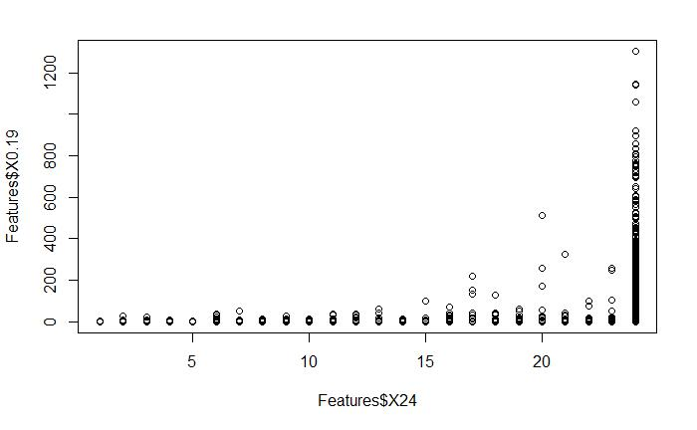

The coding and the main output are given below

Features_Train<-Features_norm[1:28003,] Features_Test<-Features_norm[28004:40948,] library(neuralnet)

model<-glm(X0.19~X634995+X0+X463+X1+X0.0+X806.0+X11.291044776119403+X1.0+X70. 49513846124168+X0.0.1+X806.0.1+X7.574626865671642+X0.0.2+X69.435826365571+X0. 0.3+X76.0+X2.6044776119402986+X0.0.4+X8.50550186882253+X0.0.5+X806.0.2+X10.64 9253731343284+X1.0.1+X70.25478763764251+X.69.0+X806.0.3+X4.970149253731344,da ta = Features_Train, family = binomial)

- Warning in eval(family$initialize): non-integer #successes in a binomial
- glm!

model

##
- Call: glm(formula = X0.19 ~ X634995 + X0 + X463 + X1 + X0.0 + X806.0 +
- X11.291044776119403 + X1.0 + X70.49513846124168 + X0.0.1 +

- X806.0.1 + X7.574626865671642 + X0.0.2 + X69.435826365571 +
- X0.0.3 + X76.0 + X2.6044776119402986 + X0.0.4 + X8.50550186882253 +
- X0.0.5 + X806.0.2 + X10.649253731343284 + X1.0.1 + X70.25478763764251
+
- X.69.0 + X806.0.3 + X4.970149253731344, family = binomial,
- data = Features_Train)

 | ##
 | ## Coefficients:
 | ## |  | (Intercept) |  |  | X634995 | X0
 | ## |  | -8.1890 |  |  | 15.1657 | 0.6445
 | ## |  |  | X463 |  | X1 | X0.0
 | ## |  | -23.2171 |  |  | -0.7102 | -26.2338
 | ## |  | X806.0 |  |  | X11.291044776119403 | X1.0
 | ## |  | 2.0551 |  |  | 157.0660 | 4.4092
 | ## |  | X70.49513846124168 |  |  | X0.0.1 | X806.0.1
 | ## |  | -8.4151 |  |  | -10.0358 | -6.5078
 | ## |  | X7.574626865671642 |  |  | X0.0.2 | X69.435826365571
 | ## |  | 10.7507 |  |  | 12.4957 | 3.7177
 | ## |  | X0.0.3 |  |  | X76.0 | X2.6044776119402986
 | ## |  | -11.5462 |  |  | 4.2625 | 1.7392
 | ## |  | X0.0.4 |  |  | X8.50550186882253 | X0.0.5
 | ## |  | -4.4118 |  |  | -6.5585 | 18.3120
 | ## |  | X806.0.2 |  |  | X10.649253731343284 | X1.0.1
 | ## |  | -1.0349 |  |  | -113.9644 | -23.7730
 | ## |  | X70.25478763764251 |  |  | X.69.0 | X806.0.3
 | ## |  | 8.9179 |  |  | 3.4798 | 5.6877
 | ## |  | X4.970149253731344
 | ## |  |  | NA
 | ##

## Degrees of Freedom: 28002 Total (i.e. Null); 27976 Residual

## | Null Deviance: | 734.5
## | Residual Deviance: 505.6 |  | AIC: 498.2

summary(model)

##

## Call:
- glm(formula = X0.19 ~ X634995 + X0 + X463 + X1 + X0.0 + X806.0 +
- X11.291044776119403 + X1.0 + X70.49513846124168 + X0.0.1 +

- X806.0.1 + X7.574626865671642 + X0.0.2 + X69.435826365571 +
- X0.0.3 + X76.0 + X2.6044776119402986 + X0.0.4 + X8.50550186882253 +
- X0.0.5 + X806.0.2 + X10.649253731343284 + X1.0.1 + X70.25478763764251
+
- X.69.0 + X806.0.3 + X4.970149253731344, family = binomial,
- data = Features_Train)

 | ##
 | ## Deviance Residuals:
 | ## |  |  | Min | 1Q | Median |  |  | 3Q | Max
 | ## -0.59736 -0.07115 |  |  |  |  | -0.05908 |  | -0.02997 |  | 2.59350
 | ##
 | ## Coefficients: (1 not defined because of singularities)
 | ## |  |  |  |  | Estimate Std. Error z value Pr(>|z|)
 | ## (Intercept) |  |  |  |  | -8.1890 |  | 2.0025 |  | -4.089 4.33e-05 ***
 | ## X634995 |  |  |  |  | 15.1657 |  | 7.1199 |  | 2.130 | 0.03317 |  |  |  | *
 | ## X0 |  |  |  |  | 0.6445 |  | 0.7299 |  | 0.883 | 0.37721
 | ## X463 |  |  |  |  | -23.2171 |  | 8.4336 |  | -2.753 | 0.00591 **
 | ## X1 |  |  |  |  | -0.7102 |  | 0.6881 |  | -1.032 | 0.30200
 | ## X0.0 |  |  |  |  | -26.2338 |  | 70.6481 |  | -0.371 | 0.71039
 | ## X806.0 |  |  |  |  | 2.0551 |  | 4.4873 |  | 0.458 | 0.64696
 | ## X11.291044776119403 |  |  |  |  | 157.0660 |  | 110.2234 |  | 1.425 | 0.15416
 | ## X1.0 |  |  |  |  | 4.4092 |  | 47.7658 |  | 0.092 | 0.92645
 | ## X70.49513846124168 |  |  |  |  | -8.4151 |  | 20.2766 |  | -0.415 | 0.67813
 | ## X0.0.1 |  |  |  |  | -10.0358 |  | 23.2964 |  | -0.431 | 0.66662
 | ## X806.0.1 |  |  |  |  | -6.5078 |  | 4.5938 |  | -1.417 | 0.15658
 | ## X7.574626865671642 |  |  |  |  | 10.7507 |  | 35.1815 |  | 0.306 | 0.75993
 | ## X0.0.2 |  |  |  |  | 12.4957 |  | 18.7866 |  | 0.665 | 0.50596
 | ## X69.435826365571 |  |  |  |  | 3.7177 |  | 4.9712 |  | 0.748 | 0.45455
 | ## X0.0.3 |  |  |  |  | -11.5462 |  | 19.7890 |  | -0.583 | 0.55958
 | ## X76.0 |  |  |  |  | 4.2625 |  | 2.3504 |  | 1.813 | 0.06976 .
 | ## X2.6044776119402986 |  |  |  |  | 1.7392 |  | 6.1798 |  | 0.281 | 0.77838
 | ## X0.0.4 |  |  |  |  | -4.4118 |  | 5.1254 |  | -0.861 | 0.38937
 | ## X8.50550186882253 |  |  |  |  | -6.5585 |  | 5.5094 |  | -1.190 | 0.23388
 | ## X0.0.5 |  |  |  |  | 18.3120 |  | 64.8921 |  | 0.282 | 0.77780
 | ## X806.0.2 |  |  |  |  | -1.0349 |  | 4.4386 |  | -0.233 | 0.81564
 | ## X10.649253731343284 -113.9644 |  |  |  |  |  |  | 86.4334 |  | -1.319 | 0.18733
 | ## X1.0.1 |  |  |  |  | -23.7730 |  | 34.6937 |  | -0.685 | 0.49320
 | ## X70.25478763764251 |  |  |  |  | 8.9179 |  | 19.8051 |  | 0.450 | 0.65250
 | ## X.69.0 |  |  |  |  | 3.4798 |  | 4.0256 |  | 0.864 | 0.38736
 | ## X806.0.3 |  |  |  |  | 5.6877 |  | 4.8682 |  | 1.168 | 0.24267
 | ## X4.970149253731344 |  |  |  |  |  | NA |  | NA | NA |  | NA
 | ## ---
 | ## Signif. codes: |  |  |  | 0 '***' 0.001 |  |  | '**' 0.01 '*' 0.05 '.' 0.1 ' ' 1
 | ##
 | ## (Dispersion parameter for binomial family taken to be 1)
 | ##
 | ## |  |  | Null deviance: 734.54 |  |  | on | 28002 | degrees of freedom
 | ## Residual deviance: 505.64 |  |  |  |  |  | on | 27976 | degrees of freedom

- AIC: 498.16

- Number of Fisher Scoring iterations: 9

predict<-predict(model)

head(predict)

## | 1 | 2 | 3 | 4 | 5 | 6
## | -5.584117 | -5.584117 | -5.584117 | -5.584117 -5.584117 -5.584117

fit <- glm(X0.19~X634995+X0+X463+X1+X0.0+X806.0+X11.291044776119403+X1.0+X70. 49513846124168+X0.0.1+X806.0.1+X7.574626865671642+X0.0.2+X69.435826365571+X0. 0.3+X76.0+X2.6044776119402986+X0.0.4+X8.50550186882253+X0.0.5+X806.0.2+X10.64 9253731343284+X1.0.1+X70.25478763764251+X.69.0+X806.0.3+X4.970149253731344,da ta = Features_Train, family = binomial(link='logit'))

- Warning in eval(family$initialize): non-integer #successes in a binomial

- glm!

summary(fit)

##

- Call:

- glm(formula = X0.19 ~ X634995 + X0 + X463 + X1 + X0.0 + X806.0 +
- X11.291044776119403 + X1.0 + X70.49513846124168 + X0.0.1 +
- X806.0.1 + X7.574626865671642 + X0.0.2 + X69.435826365571 +
- X0.0.3 + X76.0 + X2.6044776119402986 + X0.0.4 + X8.50550186882253 +
- X0.0.5 + X806.0.2 + X10.649253731343284 + X1.0.1 + X70.25478763764251
+
- X.69.0 + X806.0.3 + X4.970149253731344, family = binomial(link = "logi
t"),
- data = Features_Train)

 | ##
 | ## Deviance Residuals:
 | ## |  | Min | 1Q | Median | 3Q | Max
 | ## -0.59736 |  |  | -0.07115 | -0.05908 | -0.02997 | 2.59350
 | ##
 | ## Coefficients: (1 not defined because of singularities)
 | ## |  |  |  | Estimate Std. Error z value Pr(>|z|)
 | ## (Intercept) |  |  |  | -8.1890 | 2.0025 | -4.089 4.33e-05 ***
 | ## X634995 |  |  |  | 15.1657 | 7.1199 | 2.130 | 0.03317 |  | *
 | ## X0 |  |  |  | 0.6445 | 0.7299 | 0.883 | 0.37721
 | ## X463 |  |  |  | -23.2171 | 8.4336 | -2.753 | 0.00591 |  | **
 | ## X1 |  |  |  | -0.7102 | 0.6881 | -1.032 | 0.30200
 | ## X0.0 |  |  |  | -26.2338 | 70.6481 | -0.371 | 0.71039

 | ## X806.0 | 2.0551 | 4.4873 | 0.458 | 0.64696
 | ## X11.291044776119403 | 157.0660 | 110.2234 | 1.425 | 0.15416
 | ## X1.0 | 4.4092 | 47.7658 | 0.092 | 0.92645
 | ## X70.49513846124168 | -8.4151 | 20.2766 | -0.415 | 0.67813
 | ## X0.0.1 | -10.0358 | 23.2964 | -0.431 | 0.66662
 | ## X806.0.1 | -6.5078 | 4.5938 | -1.417 | 0.15658
 | ## X7.574626865671642 | 10.7507 | 35.1815 | 0.306 | 0.75993
 | ## X0.0.2 | 12.4957 | 18.7866 | 0.665 | 0.50596
 | ## X69.435826365571 | 3.7177 | 4.9712 | 0.748 | 0.45455
 | ## X0.0.3 | -11.5462 | 19.7890 | -0.583 | 0.55958
 | ## X76.0 | 4.2625 | 2.3504 | 1.813 | 0.06976 .
 | ## X2.6044776119402986 | 1.7392 | 6.1798 | 0.281 | 0.77838
 | ## X0.0.4 | -4.4118 | 5.1254 | -0.861 | 0.38937
 | ## X8.50550186882253 | -6.5585 | 5.5094 | -1.190 | 0.23388
 | ## X0.0.5 | 18.3120 | 64.8921 | 0.282 | 0.77780
 | ## X806.0.2 | -1.0349 | 4.4386 | -0.233 | 0.81564
 | ## X10.649253731343284 -113.9644 |  | 86.4334 | -1.319 | 0.18733
 | ## X1.0.1 | -23.7730 | 34.6937 | -0.685 | 0.49320
 | ## X70.25478763764251 | 8.9179 | 19.8051 | 0.450 | 0.65250
 | ## X.69.0 | 3.4798 | 4.0256 | 0.864 | 0.38736
 | ## X806.0.3 | 5.6877 | 4.8682 | 1.168 | 0.24267
 | ## X4.970149253731344 | NA | NA | NA | NA

- ---

- Signif. codes: 0 '***' 0.001 '**' 0.01 '*' 0.05 '.' 0.1 ' ' 1

- (Dispersion parameter for binomial family taken to be 1)

##

- Null deviance: 734.54 on 28002 degrees of freedom
- Residual deviance: 505.64 on 27976 degrees of freedom
- AIC: 498.16
##
## Number of Fisher Scoring iterations: 9

library(ResourceSelection)

## ResourceSelection 0.3-2 2017-02-28

hoslem.test(Features_Train$X0.19, fitted(fit))

##

- Hosmer and Lemeshow goodness of fit (GOF) test

- data: Features_Train$X0.19, fitted(fit)
- X-squared = 14.466, df = 8, p-value = 0.07041

#plot the fitted model
plot(fit$fitted.values)
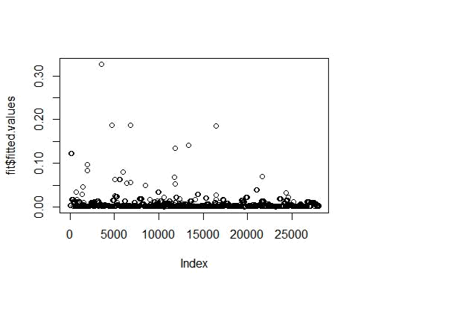

- <- 1:20

- <- 21:40 library(MASS) boxcox(y~x)

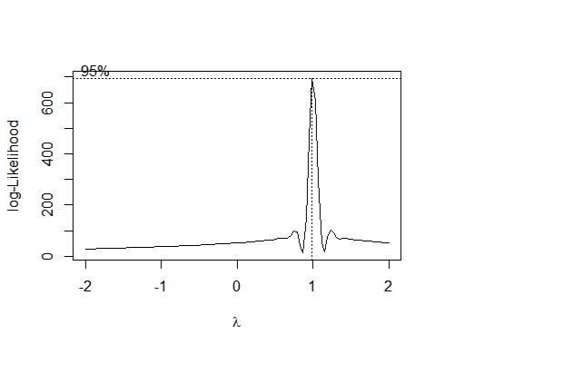

plot(1/y^2~x)
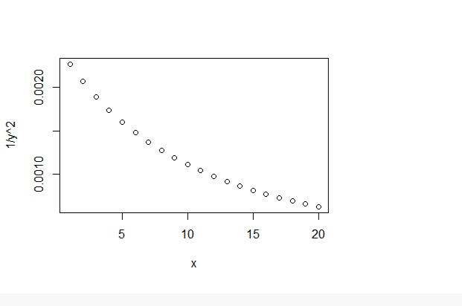

g <- roc(X0.19~ pred, data = Features_Test)
g

##
- Call:
- roc.formula(formula = X0.19 ~ pred, data = Features_Test)

- Data: pred in 6868 controls (X0.19 0) < 1759 cases (X0.19 0.00076628352490 4215).

- Area under the curve: 0.6101

plot(g)
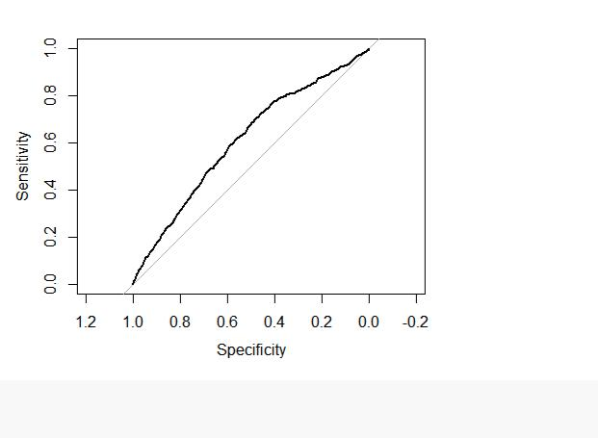

library(caret)

- Loading required package: lattice

- Loading required package: ggplot2

#with default prob cut 0.50
Features_Test$pred_X0.19 <- ifelse(pred<0.7,'yes','no')

table(Features_Test$pred_X0.19,Features_Test$X0.19)

## | 29788 0.0000000000 | yes -5.8735363
## | [ reached getOption("max.print") -- omitted 11160 rows ]

# summarize results

#confusionMatrix<- confusionMatrix(pred$predictions,pred$X0.19)

#confusionMatrix

barchart(Features_Test$pred_X0.19)
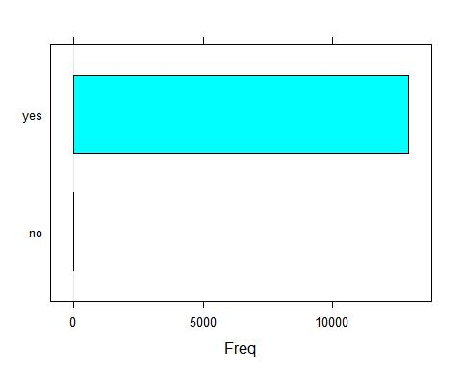

Neural Network model prediction

library(readr)

dataset <- read_delim("Dataset.zip", ";", escape_double = FALSE, trim_ws = TRUE)

View(Features_TestSet)

dim(Features_TestSet)

head(Features_TestSet)

str(Features_TestSet)

names(Features_TestSet)
dim(Features_Variant_1)

Features<-Features_Variant_1

names(Features)

head(Features)

head(Test_Case_1)

normalize<-function(x) {return((x-min(x))/(max(x)-min(x)))}

Features_norm<-as.data.frame(lapply(Features,normalize))
Features_norm
names(Features_norm)
Features_Train<-Features_norm[1:28003,]
Features_Test<-Features_norm[28004:40948,]
library(neuralnet)
set.seed(123)

Features_model<-neuralnet(X0_19~
X634995+X0+X463+X1+X0.0+X806.0+X11.291044776119403+X1.0+X70.49513846124168+X0.0_1+X806.
0_1+X7.574626865671642+X0.0_2+X69.435826365571+X0.0_3+X76.0+X2.6044776119402986+X0.0_4+
X8.50550186882253+X0.0_5+X806.0_2+X10.649253731343284+X1.0_1+X70.25478763764251+X.69.0+
X806.0_3+X4.970149253731344+X0.0_6+X69.85058043098057+X0_1+X0_2+X0_3+X0_4+X0_5+X65+X1

66+X2,data = Features_Train)

plot(Features_model)

model_results<-compute(Features_model,Features_Test[1:37])

predicted_X0_19<-model_results$net.result

nrow(predicted_X0_19)

head(predicted_X0_19)

round(cor( predicted_X0_19,Features_Test$X0_19),2)

[1] 12945

[,1]

28004 0.001069433699

28005 0.001070214932

28006 0.001087235290

28007 0.001069451002

28008 0.001589321488

28009 0.001273782979

[,1]

[1,] 0.65

The correlation (0.65) is the highest than the others given below. Higher is better.

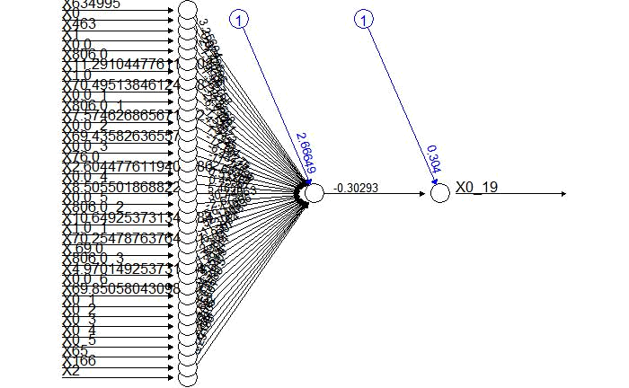

set.seed(123)

Features_model<-

neuralnet(X0_19~X634995+X0+X463+X1+X0.0+X806.0+X11.291044776119403+X1.0+X70.49513846124 168+X0.0_1+X806.0_1+X7.574626865671642+X0.0_2+X69.435826365571+X0.0_3+X76.0+X2.60447761 19402986+X0.0_4+X8.50550186882253+X0.0_5+X806.0_2+X10.649253731343284+X1.0_1+X70.254787 63764251+X.69.0+X806.0_3+X4.970149253731344,data = Features_Train)

plot(Features_model) Model1
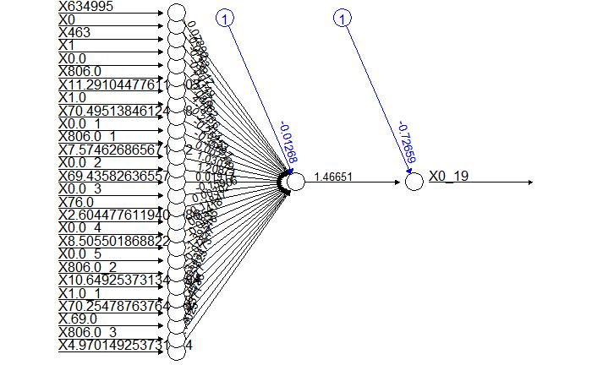

Model2
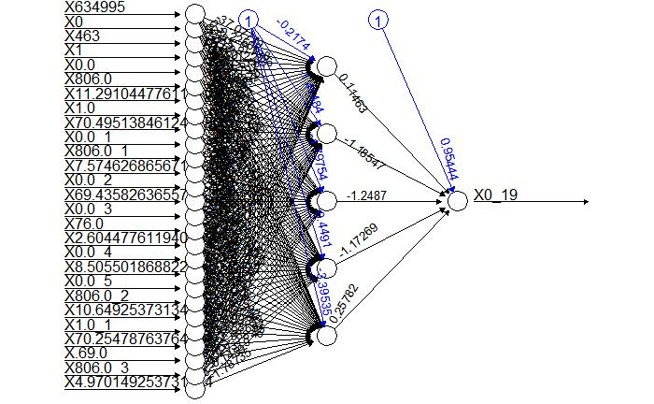

model_results<-compute(Features_model,Features_Test[1:27])

predicted_X0_19<-model_results$net.result

nrow(predicted_X0_19)

head(predicted_X0_19)

round(cor( predicted_X0_19,Features_Test$X0_19),2)

[1] 12945

[,1]

28004 0.002802219847

28005 0.002802219847

28006 0.002802219847

28007 0.002802219847

28008 0.002802219847

28009 0.002802219847

[,1]

[1,] 0.34
set.seed(123)

Features_model<-

neuralnet(X0.19~X634995+X0+X463+X1+X0.0+X806.0+X11.291044776119403+X1.0+X70.495138461241

68+X0.0.1+X806.0.1+X7.574626865671642,data = Features_Train)

plot(Features_model)

Model1
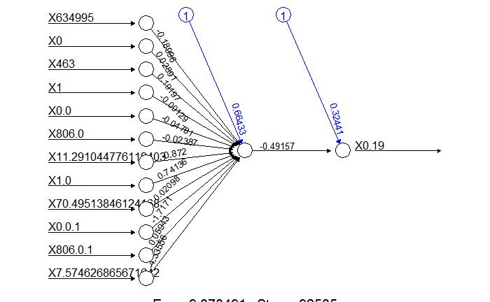

Model2
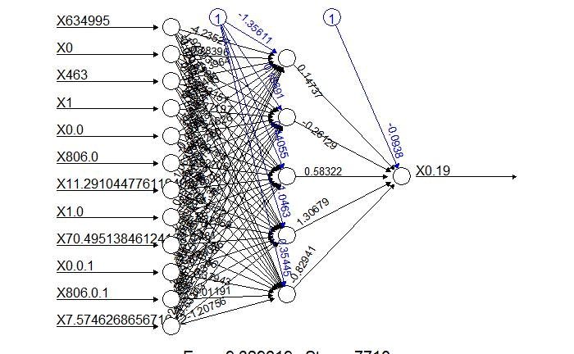

Model1

[1] 12945

[,1]

28004 0.002660508374

28005 0.002660508374

28006 0.002660508374

28007 0.002660508374

28008 0.002660508374

28009 0.002660508374

[,1]

[1,] 0.34

Model2

[1] 12945

[,1]

28004 0.001997766546

28005 0.001997766546

28006 0.001997766546

28007 0.001997766546

28008 0.001997766546

28009 0.001997766546

[,1]

[1,] 0.32

non-integer #successes in a binomial glm!

Call: glm(formula = X0.19 ~ X634995 + X0 + X463 + X1 + X0.0 + X806.0 + X11.291044776119403 + X1.0 + X70.49513846124168 + X0.0.1 +

X806.0.1 + X7.574626865671642 + X0.0.2 + X69.435826365571 +

X0.0.3 + X76.0 + X2.6044776119402986 + X0.0.4 + X8.50550186882253 +

X0.0.5 + X806.0.2 + X10.649253731343284 + X1.0.1 + X70.25478763764251 + X.69.0 + X806.0.3 + X4.970149253731344, family = binomial, data = Features_Train)

Coefficients:
(Intercept) |  | X634995 |  | X0
X463
-8.1889873 |  | 15.1656626 |  | 0.6445092 | -
23.2171336
X1 |  | X0.0 |  | X806.0
X11.291044776119403
-0.7102152 |  | -26.2338417 |  | 2.0551480
157.0660451
X1.0 | X70.49513846124168 |  |  | X0.0.1
X806.0.1
4.4092485 |  | -8.4150733 |  | -10.0357869 | -
6.5077822
X7.574626865671642 |  | X0.0.2 |  | X69.435826365571
X0.0.3
10.7507051 |  | 12.4957414 |  | 3.7176835 | -
11.5461700
X76.0 | X2.6044776119402986 |  |  | X0.0.4
X8.50550186882253
4.2624506 |  | 1.7391687 |  | -4.4118131 | -
6.5584531
X0.0.5 |  | X806.0.2 | X10.649253731343284
X1.0.1
18.3120490 |  | -1.0348589 |  | -113.9643962 | -
23.7729803
X70.25478763764251 |  | X.69.0 |  | X806.0.3
X4.970149253731344
8.9179436 |  | 3.4798448 |  | 5.6876570
NA
Degrees of Freedom: 28002 Total (i.e. Null); |  |  |  | 27976 Residual
Null Deviance: | 734.5361
Residual Deviance: 505.6398 |  | AIC: 498.1562

